**Note Taking App with FLASK**

**Background:**

Being an enthusiast data scientist I also wanted to gain knowledge of Backend App development. The internship I am enrolled in gave me a chance to practice and learn by refactoring and fixing bug of an existing code written for a Note taking app.

**Task:**

The major task is to fix and all bugs in the existing code and refactor it for smooth functioning. There is no scratch work done but taking the existing code as foundation the whole simple model is developed.

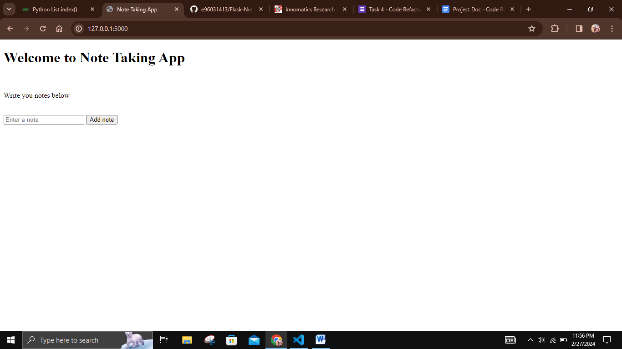

This is a simple flask note taking app that helps users to create, view and delete their notes.

**Python Library used:**

The major library used is flask and from flask, Flask, render_template, request, redirect and url_for are used.

**About the usage of APP:**

Creating: There is an input section to enter the note by the user. The note will get saved by clicking on the Add Note button just beside the input.

Viewing: All notes are displayed on the home page.

Deleting: To delete a note, click on the delete button under the note.

**Refactor work description:**

**Changes made in the home.html file:**

* Method = POST is added for form tag since the request is sent in post form.
* In Add note button, type = Submit is added for the functionality of button.
* Instead of unordered list, Jinja templating is used for notes display.
* Each node is provided with a delete button, which when clicked redirect to the delete route that includes index of the note in list notes.

**Changes made in the app.py file:**

* request, redirect and url_for are additionaly imported.
* Home page route (‘/’) is provided with two methods POST and GET.
* If condition is added for post request, when note is added.
* Redirect is used for returning back to same home page after note is added to notes list.
* url_for is used to get the index url.
* One more route is added for deletion of the note which takes the user to a post request.
* Under the delete route the delete function removes the selected note from the list.
* Again redirect is used for coming back to same page after deletion of note.

**Overall working of APP:**

Once the user types the note and click Add note, the particular note gets appended into the notes list. And all the notes are displayed on the same page. When user clicks the delete button underneath the note it direct to delete route that first finds the index of the note, and then remove the note from the notes list using this index.